Ideation Phase

Brainstorm & Idea Prioritization Worksheet

Date | 7 August 2026
Student Name | DEEPAK C
Project Name | Shopez : E-Commerce Application
Maximum Marks | 4 Marks

Step 1: Team Formation & Problem Framing

TEAM FORMATION | PROBLEM STATEMENT  How can we build a secure and user-friendly e-commerce platform that enables customers to easily browse, compare, and purchase products online, while providing sellers and administrators with an efficient way to manage products, inventory, orders, payments, and customer information—all within a single integrated system? | PROBLEM SELECTED

Step 2: Brainstorming — Idea Capture & Clustering

Core Booking Flow
Security & Roles
Patient Experience

Product Browsing
Cart & Checkout
Order Management

User Authentication
Role-Based Access
Secure-Payments

Product Search
Notifications
Wishlist
Order Tracking

Records & Compliance
Live Order Tracking
Multi-Vendor Support

Future Enhancements

Order History
Storage for prescriptions & reports

Step 3: Idea Prioritization (Importance vs Feasibility)

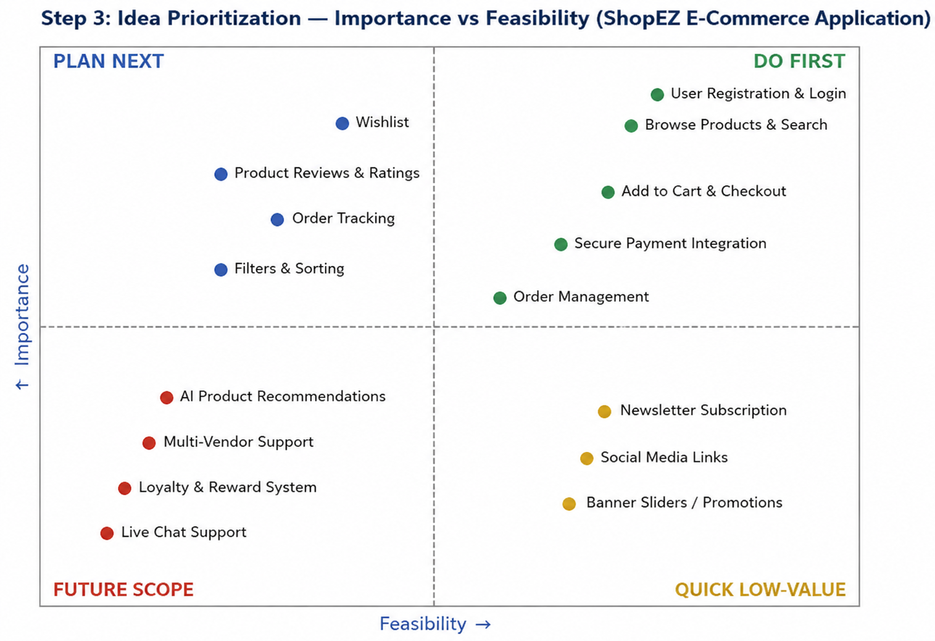

Conclusion
The features rated highest in both importance and feasibility—user authentication, product browsing, shopping cart, secure checkout, and order management—form the MVP core and were placed in the Do First quadrant. Features such as wishlist, product reviews, search and filtering, and order tracking were grouped under Plan Next, as they enhance the shopping experience after the core functionality is complete.

